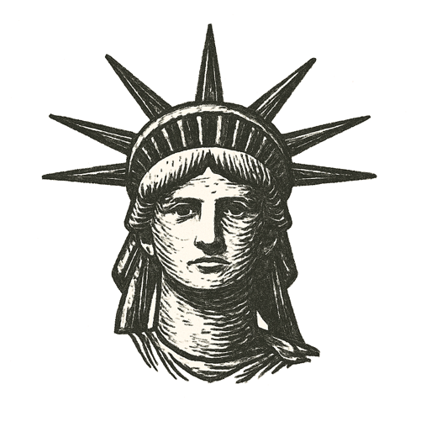
The plane waited on the tarmac, lights blinking in the humid night. The boarding stairs loomed like a narrow bridge.
I stood beneath the steel belly, two suitcases and a carry-on all that remained of my life. My breath hung in the heavy air, heart pounding loud enough to drown the silence.
Behind me lay narrow streets and silent eyes, words I could never say, thoughts punishable by death. Ahead, an unknown sky.
I climbed the steps. The door closed with a hollow thud.
Hours later, wheels struck wet tarmac. Rain hammered JFK’s runways as the plane shuddered to a stop. Somewhere beside that dark terminal, a statue raised a torch through the storm — perhaps a welcome, perhaps just another creed.
I had crossed a line no one could see.

How far must we go to be free to think?

